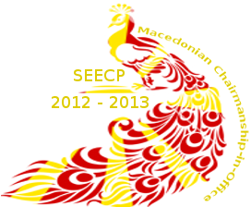
Собрание на Република Македонија

10th CONFERENCE OF The SEECP PRESIDENTS OF PARLIAMENTS

26 - 28 May 2013
Ohrid
Individual Registration Form
Please fill in and send this form to: seecp10pd@sobranie.mk
no later than 2 May, 2013.

Mr.  Ms | Firs Name:
Mr.  Ms | Last name:
Mr.  Ms | Title:
Parliament/ Organization: |  |  |  |  | Chamber:
Name of the Contact Person: |  |  | e-mail: |  |  | Telephone: |  | Fax:
Arrival |  |  |  | Departure
Date: |  | Means of transport: |  | Date: |  |  | Means of transport:
Time: |  | Flight No. / Airport/ Border crossing: |  | Time: |  |  | Flight No./ Airport/  /Border crossing:
Transfer from and to the airport: Embassy (Diplomatic Mission)

Host Parliament

Reguest for interpretation booth
for the delegation: Yes No

- Please indicate your participation at :
welcoming dinner on 26 May 2013
cultural programme on 27 May 2013
official dinner on 27 May 2013

- Please indicate if you have any dietary requirements: ___________________________________

- Blood type (only for Presidents): ____________________________________________________

- Please indicate the hotel where you have made the reservation: ___________________________

