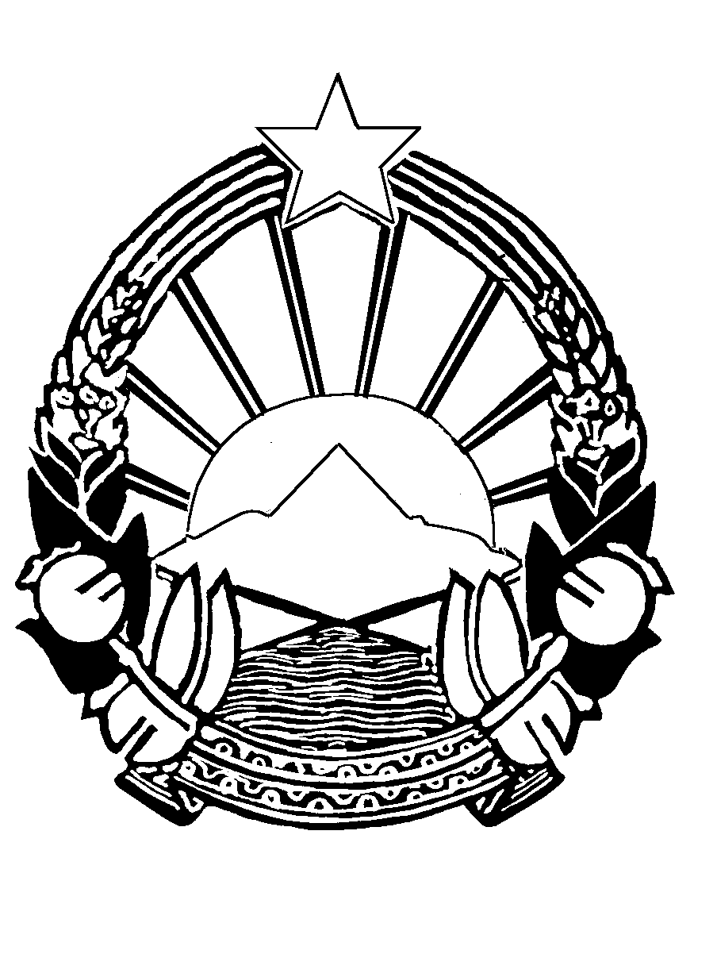
Republic of Macedonia

President

Address
by
Mr. Ljupco Jordanovski,
Acting President of the Republic of Macedonia

at the
Seventh Summit of the Heads of States and Governments of the Countries Participating in the
South East European Cooperation Process

Sarajevo, 21 April 2004

Excellencies,
Ladies and Gentlemen,
Dear friends,

Allow me in the beginning to point out that I am particularly pleased to be able, at the invitation of our hosts, the Presidency of Bosnia and Herzegovina and Mr. Sulejman Tihic, to attend today’s Summit of Heads of States and Governments of the Countries Participating in the South East European Cooperation Process.

I am convinced that at this meeting, we will once more have an opportunity for an exchange of opinions on the most topical issues of interest for our Region, confirming our commitment to continue along the road of good-neighbourliness, peace, stability and prosperity of our peoples, our states and Europe at large.

I would like to use this opportunity to repeat our deep gratitude to the leadership and the citizens of Bosnia and Herzegovina for their wholehearted assistance and support in the challenging days following the tragic death of President Trajkovski and his associates.

By participating in the four previous summits held within the South East European Cooperation Process (SEECP) in Skopje, Tirana and Belgrade, President Trajkovski, gave his contribution and impetus not only to the cooperation and activities among the countries-participants in the Process but for the entire region, and beyond.

Dear friends,

Over the past years, our countries have made important steps in their political, economic and democratic transformation. We have clearly expressed our unambiguous commitment for full European and Euro-Atlantic integration. The negotiations for EU membership with the candidate-countries from the Region, Bulgaria and Romania, advanced successfully; hopefully, they will soon be joined by Turkey. Positive answer from EC to Croatian aplication make all of us very happy. We hope that very soon, the Republic of Croatia will receive a positive answer to its Application. That would be an encouraging signal for the Republic of Macedonia, that it would be evaluated according to its efforts and merits.

We expect that in the Association and Stabilization Process we will soon be joined by the countries of Bosnia and Herzegovina, Albania and Serbia and Montenegro.

The Presidents of the countries of the Western Balkans demonstrated their commitment for regional cooperation on their way towards EU integration on their meeting in Ohrid prior to the Thessaloniki Summit.

Invaluable contribution in the EU integration was provided by the only EU member country of the region, Republic of Greece, by its efforts as an architect and host of the Thessaloniki Summit as well as by its clear, highest-level political messages that the Region of the Western Balkans indeed belongs to the European family.

We firmly believe in the democratic potential of our countries, which constitutes the basis and provides an impetus to the stabilization, sustainable development and economic prosperity of the South East European countries. The more this part of Europe is an active player and promoter of the European ideas, the closer it is going to arrive to the realization of the commitment that our future becomes part of the common European future. This approach has already delivered results: Three countries of our wider region, Slovenia, Romania and Bulgaria have already become NATO members, while on the 1st of May, Slovenia and Hungary will become EU members. We congratulate all of them sincerely.

This road is neither simple nor easy. Therefore, we should dedicate even closer attention to the mutual cooperation we have had so far and focus ourselves entirely on the European and Euro-Atlantic integration.

We are certain that in order to reach the desired objectives, we should further strengthen our mutual trust and understanding, to the benefit of our own peoples, but also to the benefit of the peoples of the neighbouring countries.

Undoubtedly, when doing so, we should respect accordingly the international law; we should try and resolve our differences in a peaceful manner, respect the existing borders, refrain from use of any kind of force or interfere in internal affairs of the states.

Ladies and Gentlemen,

Significant is the potential of the democratic awareness of all citizens of the Republic of Macedonia, who understand the essence of coexistence and the need to respect the others, regardless of their ethnic or religious background. It is this fundamental value that lies in the foundation of the coexistence of the people of Macedonia and which enabled us to come out of the spiral of the conflict.

Macedonian political leadership is fully dedicated to the implementation of the constitutional and legal changes initiated with the Framework Agreement. The results, obtained in a democratic manner, represent an achievement for the Republic of Macedonia, as well as a challenge for the wider region.

With regard to the security situation in the Republic of Macedonia, the progress is evident. We have passed a long way, and we have strengthened our internal stability by applying uncompromisingly the rule of law on the entire territory of the state.

In that sense, Republic of Macedonia continues to implement the obligations under the Stabilization and Association Agreement with the European Union, as well as to carry out the efforts to become NATO member. The European orientation and our fully-fledged membership in European and Euro-Atlantic structures remain, for our people, a firm and long-lasting commitment, raised, along with our efforts to build good-neighbourly relations, to the level of national priority.

Taking as the starting point its commitment to join the European and Euro-Atlantic structures as soon as possible, the Republic of Macedonia presented on the 22 March 2004 an Application for European Union Membership. This is a step forward in taking upon ourselves serious obligations and tasks, the implementation of which requires many years of hard work. The Stabilization and Association Agreement between the European Union and the Republic of Macedonia is the first such agreement ratified by all the Union Member-States and on the 1st of April it came into force. This is a strong impetus for us to fulfill, as soon as possible and in the best possible way, all the obligations deriving from our Application for Membership.

In the spirit of regional cooperation, and with a view to our faster integration in the NATO structures, the Republic of Macedonia, Republic of Albania and Republic of Croatia concluded the Adriatic Charter for Partnership with the United States of America. This has obliged us additionally to speed up the reforms in defense and the Army, and has increased our deserved expectations for a strong support at the Istanbul Summit for NATO membership by the end of 2007.

Ladies and Gentlemen,

Now I would like to refer to our views relating to the developments in the Region and beyond.

I am pleased to note that our joint efforts to consolidate our regional security have given continuous results with each passing day. Democratic objectives, values and ideas have more and more become our reality. Our region has over the past couple of years become recognizable for the cooperation we have been promoting. Additional efforts are, indeed, required to create democratic environment in every corner of our Region as a part of Europe. The fight against violence and crime is a fight for the good of everyone.

With respect to the relations at a wider international level, I should once again reaffirm our commitment for full solidarity with and support to the international community in the fight against terrorism and hence our readiness to take specific actions in order to provide contribution to the global efforts against this threat.

Ladies and Gentlemen,

Republic of Macedonia dedicates significant attention to the regional cooperation and endeavours to promote it in a possibility to further the good-neighbourly relations in the Region.

Regional cooperation provides opportunity to benefit from mutual advantages offered by our geographical closeness, traffic connections possibilities, comparative advantages of our economies, natural specifics and the fact that we are directed towards each others.

In this framework, we consider that the opportunities offered by the South East European Cooperation Process (SEECP) are enormous. Best evidence for this is the Croatia's announced joining of the Process as a fully-fledged member, which we commend most sincerely. Therefore, and due to the fact that an initiative is in question originated from the very countries of South Eastern Europe, we dedicate particular significance to the South East European Cooperation Process (SEECP). We consider the significant results achieved so far both a reason for content and an impulse for further joint cooperation.

We fully agree with the assessment that the impulse for regional cooperation should come from the Region itself. After all, that was the course reflected in the Skopje Action Plan for Regional Economic Cooperation, which, I am certain, is still highly relevant and deserves efforts to be invested in its implementation.

We commend the forms of communication in the Process established so far, including the numerous initiatives and concrete proposals for joint efforts in the areas of power supply, free trade agreements, infrastructural cooperation, telecommunications, fight against organized crime and other issues of interest for the Region.

We believe that the active and regular parliamentary cooperation we have had so far should continue, as it constitutes an indispensable component of the overall multilateral and bilateral cooperation in the Region. In that sense, particularly important is that, recently in Sarajevo, the parliamentary dimension of our joint efforts was revived, and the priorities were reaffirmed which had been identified in the Procedural Framework for parliamentary cooperation agreed upon at the 2001 Conference in Skopje.

As far as the specific proposals to improve the functioning of the South East European Cooperation Process (SEECP), as well as concerning the coordination of the activities with the existing regional forums and international organizations, we are ready to provide our appropriate contribution.

We believe that the future cooperation with regional initiatives and international organizations should be fully based on a partnership foundation while preserving the original identity of the Process. This cooperation will be an additional contribution to the individual efforts by the South East European Cooperation Process (SEECP) countries for their European and Euro-Atlantic integration.

Dear friends,

The future of our countries and peoples depends on ourselves and lies in our states' full integration in the European and Euro-Atlantic processes, in order to enable creation of a better and more secure place to live in, for all of us.

We firmly believe that from the Sarajevo Summit, we will again send a clear message that without the countries of the Region, the EU is incomplete and the European integration project remains unfinished. The Union's principles and values are more and more present and are being accepted by our countries. Therefore, we are rightly expecting to be given positive answer to our request for a clear European perspective for our countries in the Stabilization and Association Process, as a way towards our European integration.

Thank you for your attention.

